TECHNICAL PROJECT REPORT

# Title of Invention / Project:

**4*4*4 led cube-**

# Team Members / Inventors:

|  |  |  |  |  |  |
| --- | --- | --- | --- | --- | --- |
| **S. No.** | **Name** | **Department** | **Designation** | **Mobile** | **E-Mail** |
| 1. | KRATIN MOURYA | CSE IBM BD2 | STUDENT | 6263486370 | 123kratin@gmail.com |
| 2. | KARUNAKAR NUVVULA | CSE IBM BD2 | STUDENT | 7652889907 | karusmart24@gmail.com |
| 3. | AYUSH SARRAF | CSE IBM BD 2 | STUDENT | 9559519737 | ayushsarraf0731@gmail.com |
| 4. | MANISH JANGIR | CSE IBM BD 2 | STUDENT | 9602224036 | Jangirmanish612@gmail.com |
| 5. | YASH PAWADIA | CSE IBM BD2 | STUDENT | 9518229750 | [yashapawadia9999@gmail.com](mailto:yashapawadia9999@gmail.com) |
| 6. | Khushal Thakur | ECE | Mentor | 9646030764 | khushal.thakur@cumail.in |
| 7. | Anshul Sharma | ECE | Mentor | 9478697475 | anshulsharma.ece@cumail.in |
| 8. | Kiran Jot Singh | ECE | Mentor | 9463909689 | kiranjotsingh.ece@cumal.in |
| 9. | Divneet Singh Kapoor | ECE | Mentor | 9878422653 | divneet.ece@cumail.in |

Section – 1 (IPR Related)

# **BRIEF ABSTRACT (500 WORDS):**

# THE MAIN PURPOSE THAT THE LED CUBE SERVES IS IN THE ENTERTAINMENT SECTOR. FOR ALL INTENTS AND PURPOSES, IT IS ACTUALLY A HIGH-TECH DISPLAY. THINK OF IT AS A THREE-DIMENSIONAL DISPLAY CONSISTING OF 64 PIXELS (OR VOXELS IN THIS CASE) WHICH CAN BE USED TO VISUALISE ANY SORT OF ANIMATION OR GRAPHICS. THE CUBE HAS COMMERCIAL POTENTIAL DUE TO ITS ADVANCED AND UNPARALLELED DESIGN.

A LED CUBE IS LIKE A LED SCREEN BUT IT IS SPECIAL AS IT HAS 3D.WE CAN THINK IT AS OF LOW RESOLUTION DISPLAYS. IN NORMAL DISPLAYS IT IS NORMAL TO STACK PIXELS CLOSER TO EACH OTHER IN ORDER FOR BETTER RESOLUTION BUT LED CUBE HAS ITS LIMITS.

# LED HAS TWO LEGS ONE POSITIVE AND ONE NEGATIVE .THE POSITIVE END IS CONNECTED TO THE PILLARS OF LED CUBE WHICH ACTS AS ANODE.THE NEGATIVE ONE IS CONNECTED TO THE LAYER. HENCE TO SWITCH ON A PARTICULAR LED WE HAVE TO GIVE CURRENT TO THE CORRESPONDING PILLAR AND GROUND THE LAYER. LEDS PRESENT MANY ADVANTAGES OVER INCANDESCENT LIGHT SOURCES INCLUDING LOWER ENERGY CONSUMPTION, LONGER LIFE TIME, IMPROVED ROBUSTNESS, SMALLER SIZE, FASTER SWITCHING, EASY INSTALLATION, FRIENDLY ENVIRONMENT, AND GREATER RELIABILITY.

* **Problem your project is solving-**

This project is mainly for entertainment purpose ,and can use as a decortative purpose in our houses ,offices etc. This cube can act as a mood elevator and can divert your mind from stress causing problems for some time. This reduces stress upto some extent. This cube can be enjoyed by people in their free time by changing different pattern.

* **How are you solving that (solution)?**

By glowing the cube in different patterns in different time intervals.

* **Additional modifications that can cater to improved solution-**

The modifications or improvements we suggest and propose to improve upon is that the led cube can be made with more number of LEDs and in much more organised manner.

**Existing state-of-the-art and Drawbacks in existing state-of-the-art-**(*Brief background of the existing knowledge*)

|  |  |  |
| --- | --- | --- |
| **S. No.** | **Existing state of art** | **Drawbacks in existing state of art** |
| 1. | Can be used as a decorative purpose in home,offices ,educational institute etc. | **Cost-** In many applications, LEDs are expensive compared with other light sources. |

# **Novel/Additional modifications that you can propose to improve upon drawbacks-**

The modifications or improvements we suggest and propose to improve upon is that the led cube can be made with more number of LEDs and in much more organised manner.

**FEATURES-**

*(List down the features)*

* It is used as decorative item in various places and situations.
* It shows different patterns of blue led lights with good brightness.

**Advantages-**

(*List down the advantages, if each feature is incorporated)*

* Lifetime. As solid-state light sources, LEDs have very long lifetimes and are generally very robust.
* Standardization.
* Low maintenance.
* Efficiency.
* Low power consumption.
* Brightness.

# **Block Diagram-**

*(Functional diagram depicting the flow of information in your system. Do not define exact components, only use generic terms. Must include modifications as well.)*

Cube will glow according to uploaded cube

Current will flow from Arduino to cube

Arduino will start

Power supply is ON

Resistor will maintain the voltage

Section – 2 (Real Project)-

# **Materials-**

(*List down the Components, Equipment, etc. actually used in the project*)

1. LEDs--------------------------(64)
2. Soldering Wire
3. Soldering Machine
4. Connecting Wires(as per need)
5. PCB board----------------(1)
6. Resistors------------------(4)100ohm
7. Cello tape
8. Male headers------------(2)
9. Arduino UNO------------(1)
10. Cardboard
11. Wire Cutter
12. Power source------------(power bank,battery etc)

# **Circuit Diagram-**

(*Fully functional circuit diagram with exact connections. Can use Fritzing/Proteus*)

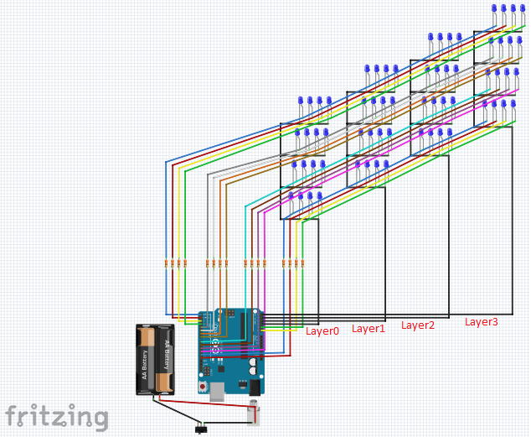

# **Steps of Circuit Completion –**

(*Bifurcate the circuit completion in steps, specify with photographs, leading to final project*)

## Step 1: Materials Required-

## **You need the following materials for making LED cube-**

1. LEDs(64)
2. Soldering Wire
3. Soldering Machine
4. Connecting Wires
5. PCB board
6. Resistors(4)100ohm
7. Cello tape
8. Male headers
9. Arduino UNO
10. Cardboard
11. Wire Cutter
12. Power source

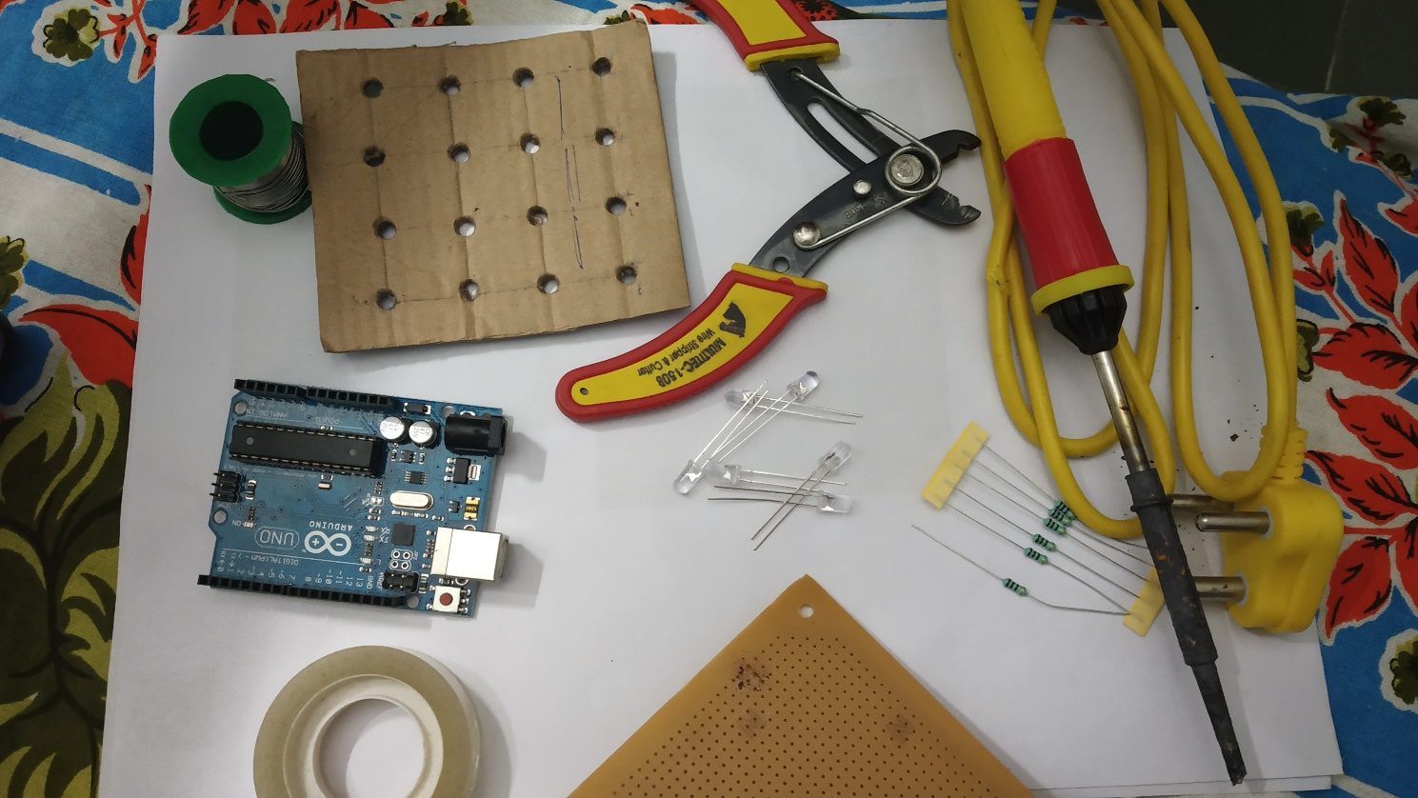

## Step 2: Test All LEDs:

1. Check for the continuity of each LED with a multi-meter.

## Step 3: Preparing a Jig:

1. Use cardboard to prepare the jig (The jig would provide a frame to make layers of LED mesh).

2. Draw a square of 4''*4'' dimensions and punch out holes.

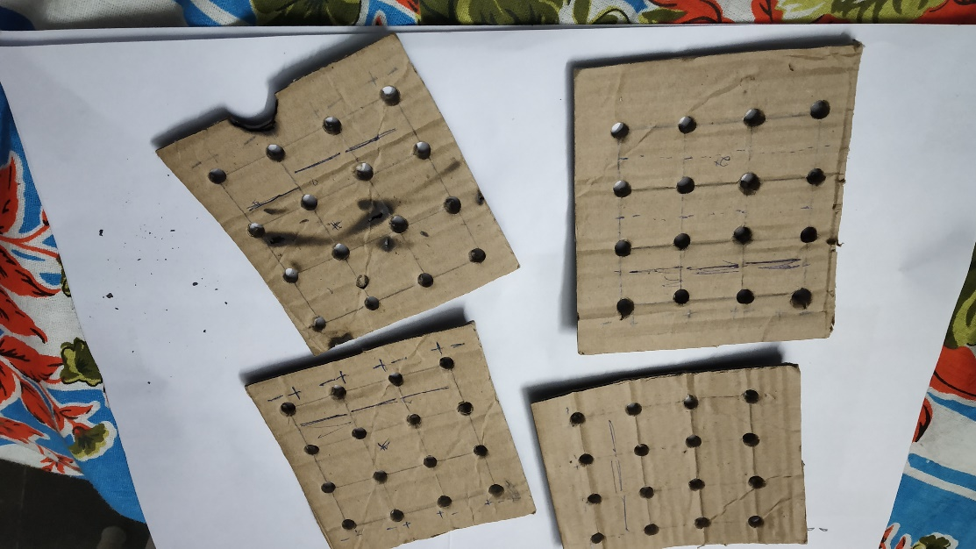

Step 5: Creating layers:

[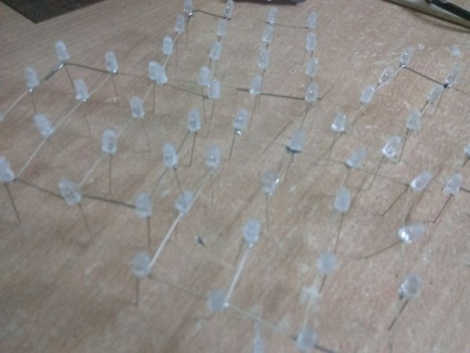](https://cdn.instructables.com/FPZ/PA30/J8UH2RU0/FPZPA30J8UH2RU0.LARGE.jpg)

1. Bend the cathode of LED perpendicular to the anode leg. Let the anode of each LED face vertically upwards.

2. Place the LED into the punched out holes in the jig.

3. Cut equal lengths of hookup wires and solder all cathode legs of the LED together.

## Step 6: Stacking Layers:

[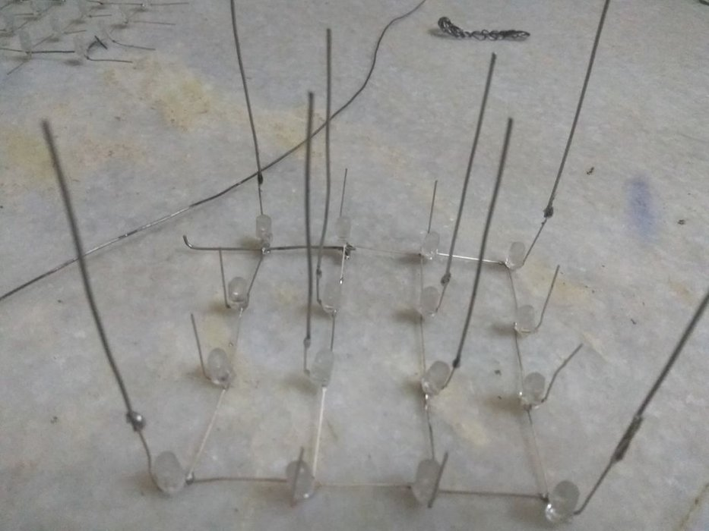](https://cdn.instructables.com/F2E/PEF3/J8UH2RWC/F2EPEF3J8UH2RWC.LARGE.jpg)

1. Thread hookup wire along the anode terminals which are facing vertically upwards,

## Step 7: Test Each Grid:

1. Test each grid with a multimeter set to continuity to rule out any defective LED or any broken contact in the grid.

2. Test the entire cube again after stacking all layers.

Steps8: Making connection with PCB and Arduino using connecting wires:

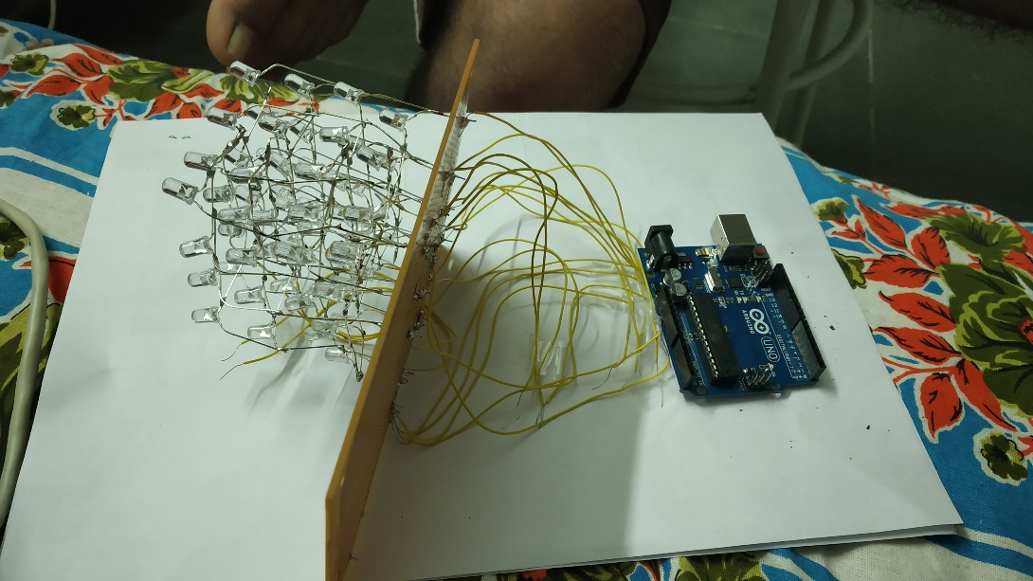

Step9: Uploading code:

# Program Code:

LINK-

https://github.com/123KRATIN/ledcube